AUT University
Industry automation system
Project proposal

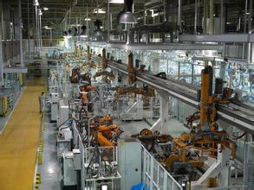

Mingyang Zhang (1256169)
Mi Dan(15880325)
Rachita Dhurandhar(1239564)
Jebby Johns(15875128)
Date:2015/8/14

Proposal Document
Introduction

Software Architecture is a set of important decision about the software structure. Which is a constituent element of the system, the interface elements, as well as choose cooperative behavior of these elements, and combine a structure with behavior elements of these compositions to be larger subsystems synthetic methods, also a set of building rules, under the guidance, these elements, interfaces, and collaborate effectively organized.

Process & Description

The ABB automation platform, named Aspect Integrator Platform (AIP), is designed to be the future platform for industrial automation applications. This platform is a part of a set of products that provide a process control system which is used to control continuous or discrete processes in various market domains, ranging from industrial systems for power plants, utilities, pulp and paper, metals and minerals, chemicals, oil and consumer industries.

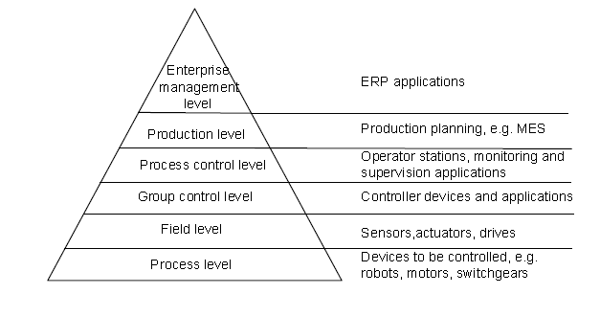
Fig 1: Industrial Automation Process
From the above diagram we can see process, field, group control process control, production, and enterprise management level In general a technical process consists of several layers. The lowest level is the process level. It contains the devices to be controlled that, On the next level, the field level, sensors, actuators, and drives provide the interface between the physical process and the control system. On the group control level, controller devices and applications control a group of devices. These process controllers obey hard real-time constraints. On the process control level, operator stations and applications supervise and control the entire process. They gather and analyze process information. The production level comprises applications for production planning, for example manufacturing execution systems (MES), which analyze and optimize entire processes with respect to production. The enterprise management level finally comprises applications with transactional character to deal with enterprise resource planning (ERP), e.g. Human resource planning, supply chain, order processing, and finance.

Investigating the problem
Industrial automation high level application (IAHLA) is used to specifically in the oil industry for controlling the oil process. These systems fundamentally include Field instrumentation, Field computers, Supervisory control and data acquisition (SCADA), Enterprise information system and human machine interface. SCADA make the data from the sensors and the control capacity of the actuators available to remote operators, applications and other systems. The control system may be combined with a data acquisition system by adding the use of coded signals over communication channels to acquire information about the status of the remote equipment for display or for recording functions.
Database is core factor in any industry. Many units use the same database for the automation process.

Research Problem:
Problem arises in the industrial automation system, when same database is used in the process. Gathering the data from different units or multiple systems into database at real time may create conflict or problem in database.

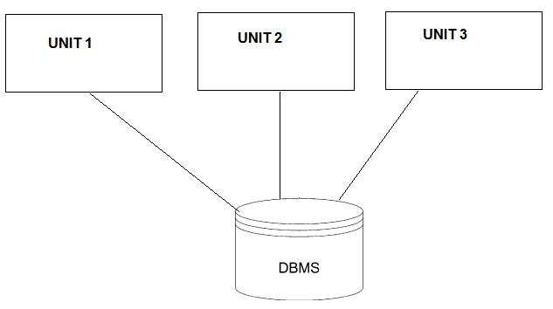
Fig 2: Unit Diagram
In above diagram, there are three units used the same database at the real time. They all are storing and retrieving the data at same time, which can be lead to the data conflict in the database. Example Unit 1 and Unit 2 want to store the same type of data at real time then database will not accept the duplication in database. Problems in database will lead to the problem in process. Database problem will lead to the data loss or delay in the whole automation process. This will affect the productivity of the factory.

Research Plan:
As this is group project we all are sharing the responsibilities of completing. We share the resources among us and do the literature review and get some final solution. Gantt chart is given below.
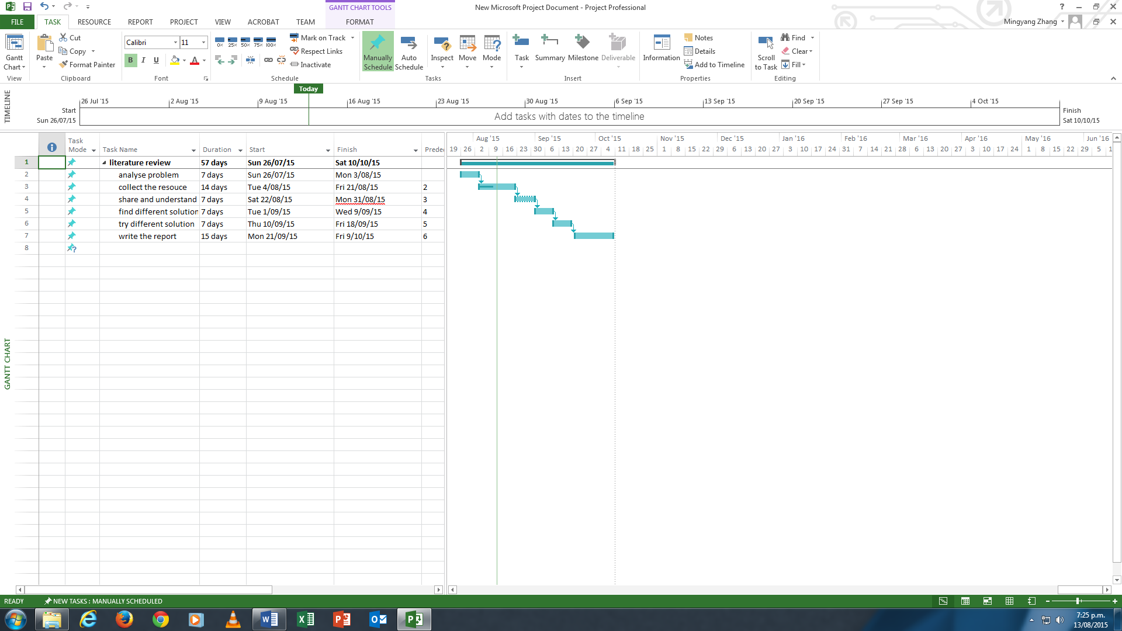

At the present we completed with the analyzing the problem. We are collecting the resources for industrial automation system.

